## Migration:

9. As Azure administrator, what you implemented?

10. What are the scripting languages you have experience?

How you will migrate application into azure and needs to decomissioning datacenter? -vNet

How you will migrate the database? How can you will connect with the application? **Hybrid connection manager**

Having exp. Infrastructure as service?

14. what you are automated as system admin?

8. In Azure resource, what kind of Azure resources and services you are having the idea?

1. **what subscription they given to you for emirates account? What is singlestack?**

<https://www.youtube.com/watch?v=FAbqJqr93v8>

3. **How to Installing patches, decommissioning in azure**

2. What you did in Azure?

1. what is workload and what are points you will consider before implementing it.

5. what is azure service vault.

8. How can you will provide security?

11. What are the steps you will follow for pre/post migration activities for workload, application, database, AD

12. How to setup landscape for AZ

13. how can you will do pricing before migrating from on premises

14. what are the steps you will follow before migration

17. What are the security aspects you will consider in Azure cloud

18. What are the services you used in PASS

19. How can you will convince stake holder to move the application from on premises to cloud

20. steps of migration of application from on premises to cloud

21. How you will provide provision for infrastracture

setup the azure landscape

## Virtual Machine:

what is Availability Set and Availability Zone?

* When we Create a Virtual Machines in Availability Sets it will increase the availability of your Applications on the other hand the Availability Zones allows you to deploy your VM’s into different data centers within the same region.

What is the availability percentage for Availability Set and Availability Zone?

Fault Domain vs Update domain

scale set vs availability set

The main difference is that **Scale Sets** have Identical VMs where in **Availability Sets** does not require them to be identical. **Scale sets** on another hand, in concept, are designed for automatic **scaling** (horizontal) in application where load can vary extensively to fulfill more compute needs

<https://www.youtube.com/watch?v=8k82BVS7P-Q>

26. How you will resolve VM performance issue? What is scale up and scale down?

**\* Performance diagnostics**.

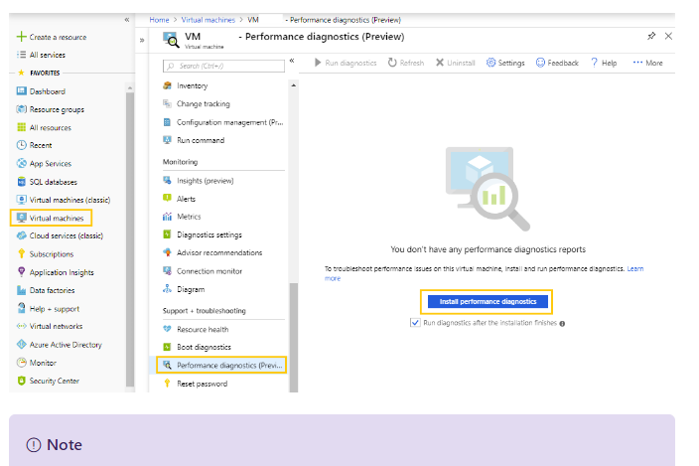

What is route table?

https://www.youtube.com/watch?v=FaAuDkojhDA

It defines how to send the traffic to your network. We will create route table create rules.

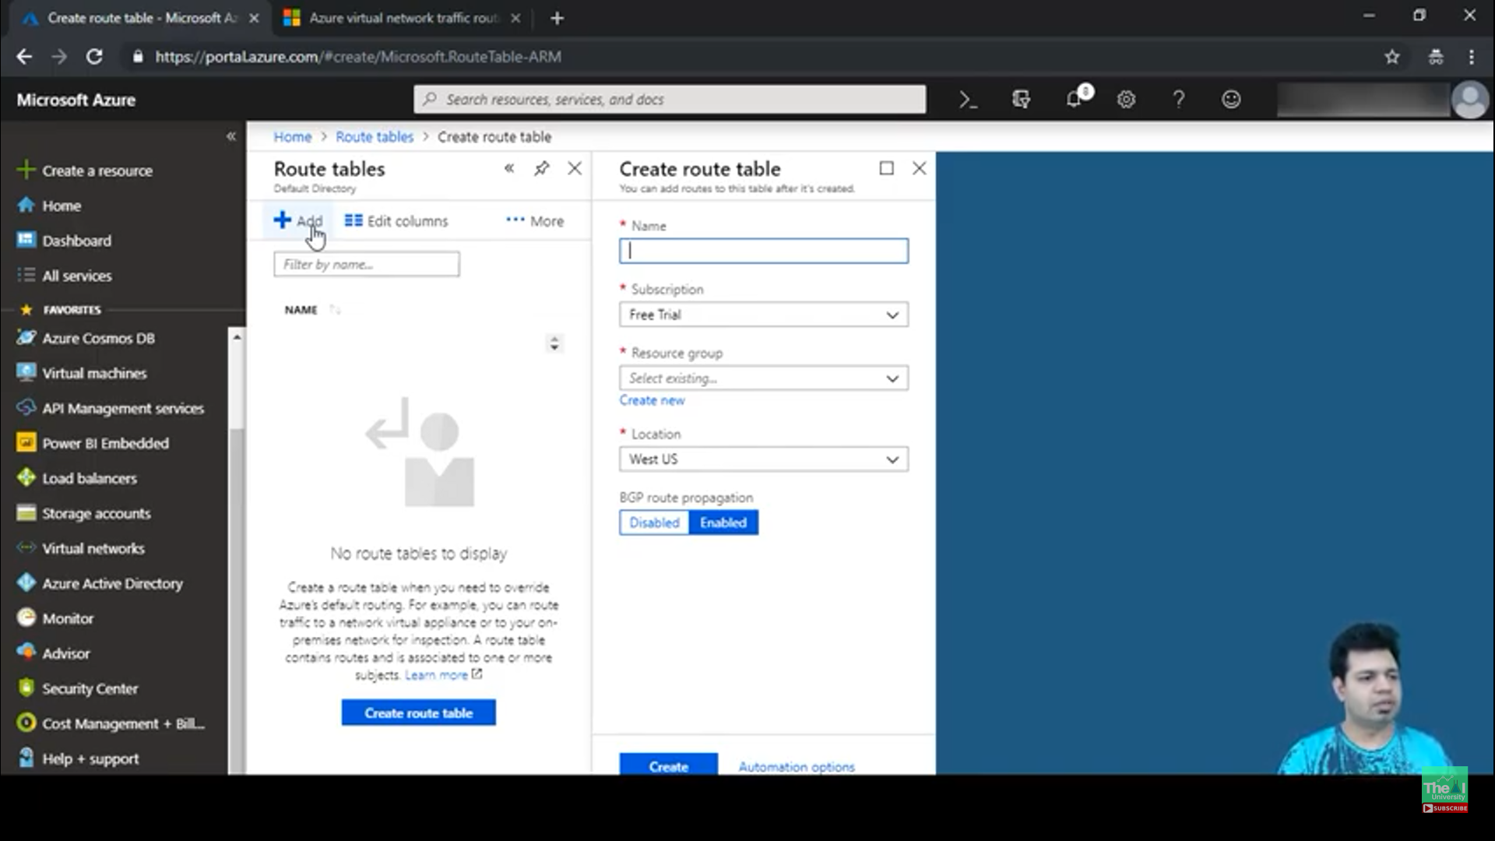

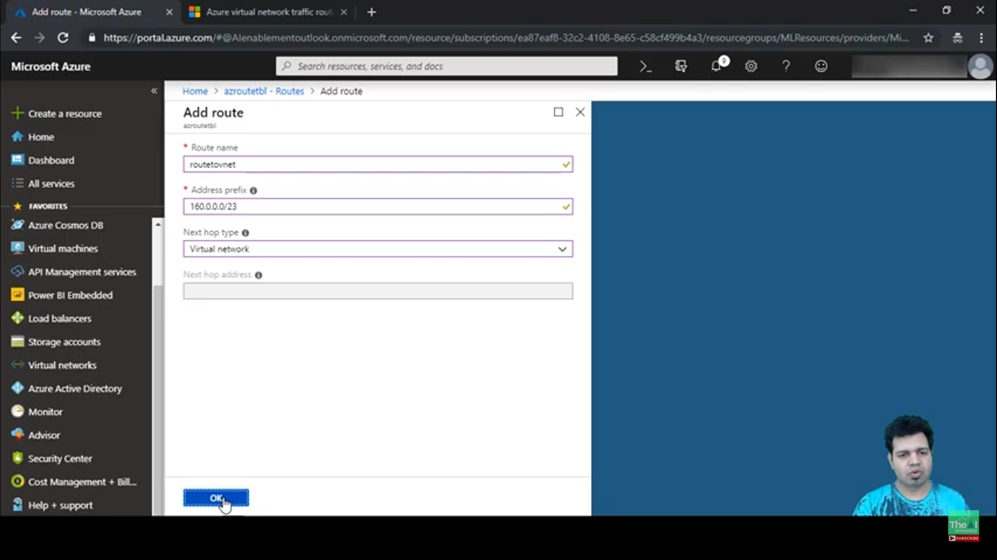

How can you will do own custom dns server for VM?

If you want to block internet in all VM within subnet how can you will do?

Under Networking tab, by creating “Outbound port rule” for internet we can restrict as shown below.

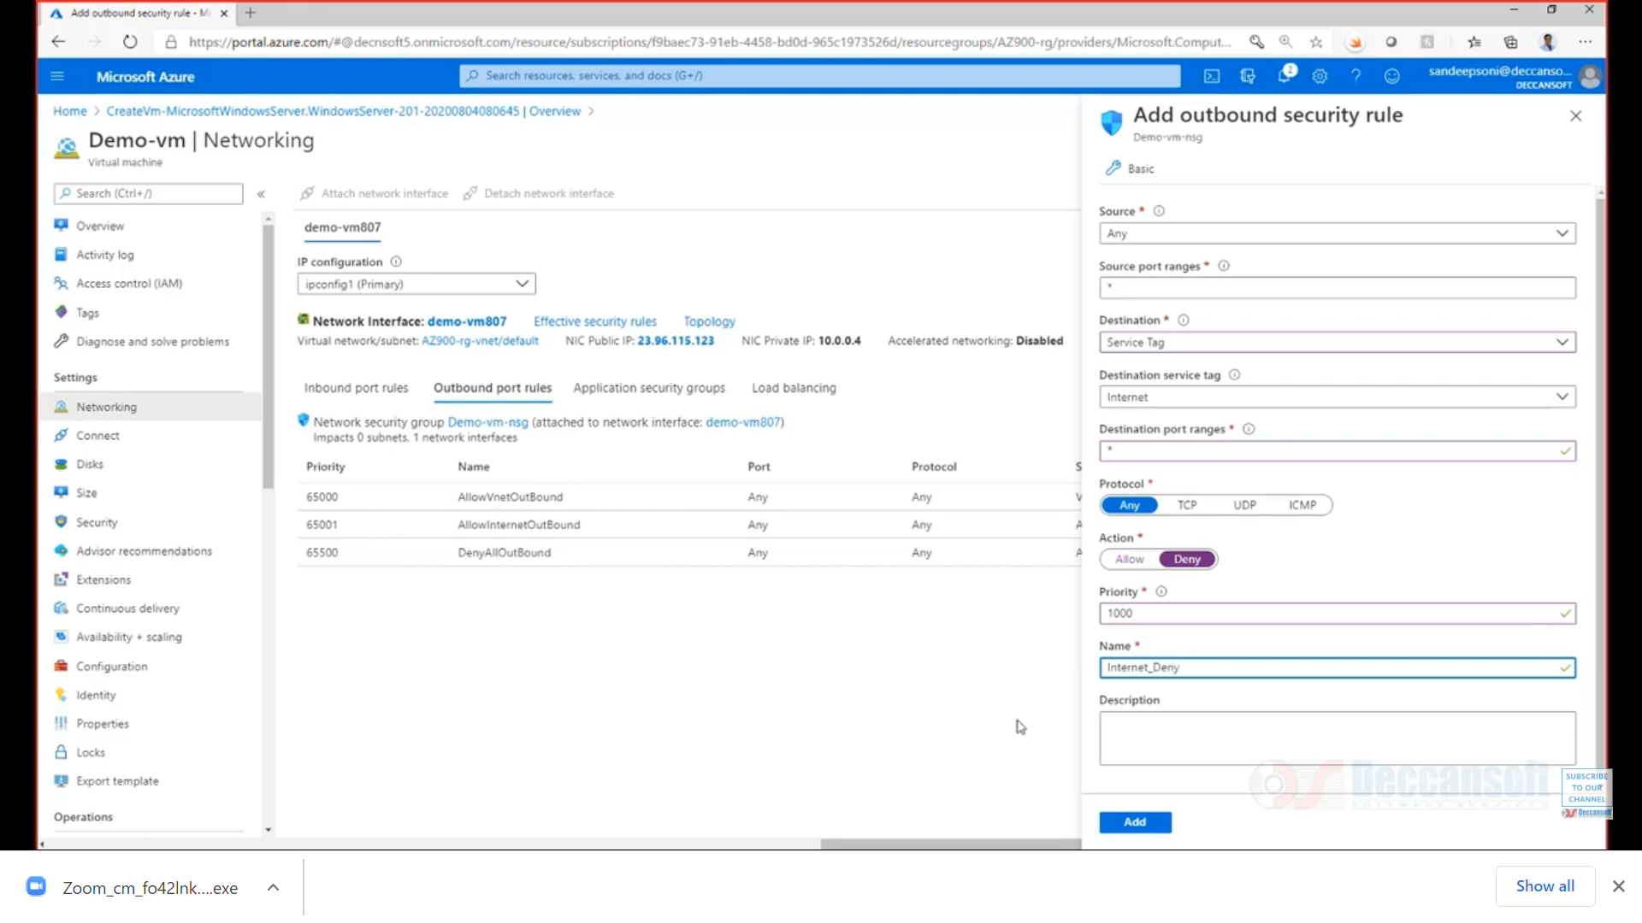

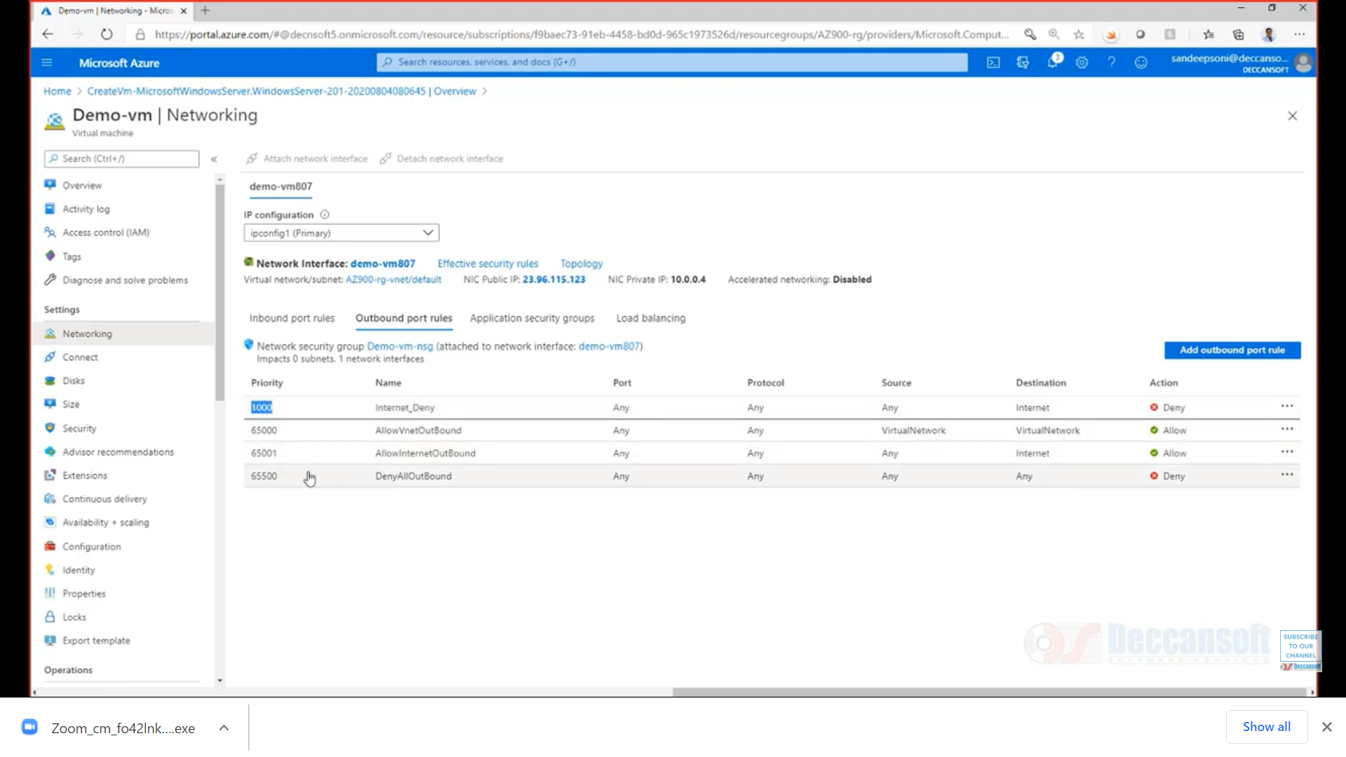

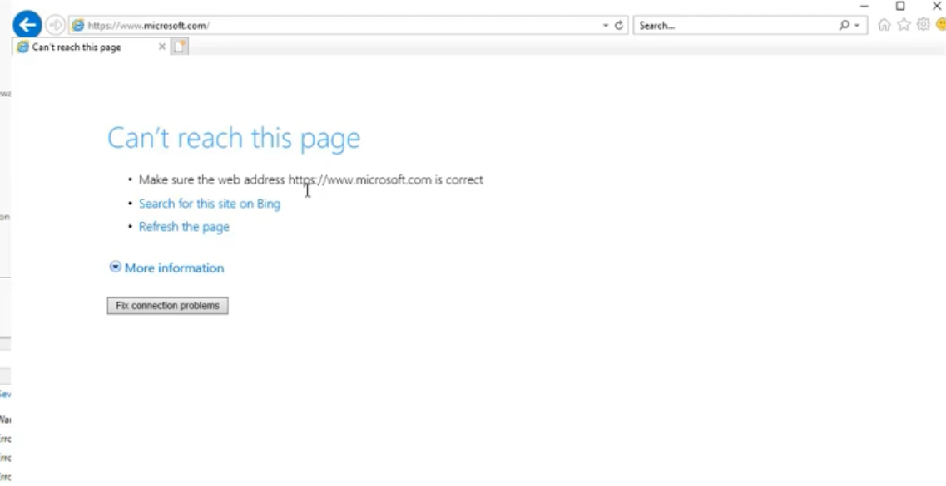

What is BAISON?

## Azure Devops

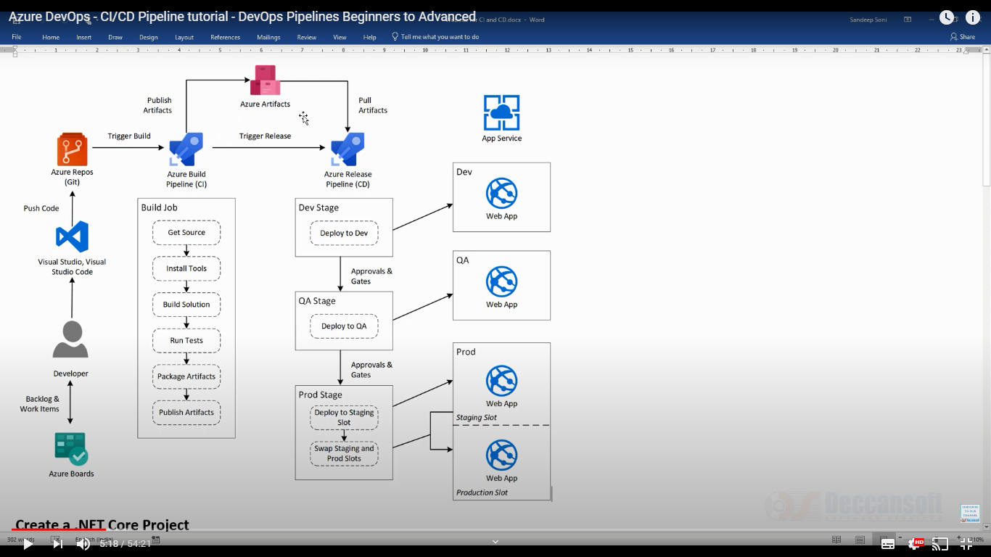

1. How many ways you can build: classic/Yaml

2. Azure build

1. What you have involved in Azure DevOps

* Creating WebApps/VM/ARM Templates

2. Explaining full flow of Azure pipeline from developer to release

3. How you will restrict the scenarios, when you commit the changes into your release branch

4. If build failed, how you will handle? Creating any Jira ticket?

If the build pipeline fails, you can automatically create a work item to track getting the problem fixed. You can specify the work item type.

You can also select if you want to assign the work item to the requestor. For example, if this is a CI build, and a team member checks in some code that breaks the build, then the work item is assigned to that person.

5. How you will configure Azure pipeline

3. How can you will deploy the source code with different environment like staging & live -Deployment Group

14. How you will do setup ARM templates for pipeline and what are the build & release management you follow

4. Pipleline

5. How to pass values during build - $(build.environment)

6. Are you familiar with YAML/Azure GUI (Classic)

7. Azure build agent- Microsoft Hosted agent & Self Hosted agents

8. how to configure TFS with azure DevOps - Self hosted Agents

9. How to configure a tool which is not available from market place

11. How you will import release pipeline in azure

12. How can you will import config changes from application to another application- **FileCopy needs to select for "Tasks"**

6. What is azure devops and how you will configure it.

7. diff b/w Jenkins and Azure DevOps

10. Define variable in Azure pipelines - $(build.environment)

11. What is Agent and agent pool

12. what is runtime parameter and how can you pass this information during build

13. TFS agent - (Self hosted agents)

How you will do deploment slot - dev/test/live

how you will integrate the devOps with userStories and backlog?

12. How to create pipeline in Azure devOps

13. Post build actions – **part of Jenkins, eg. Send mail to user once build completed**

14. where you can store these ARM template for reuse? You will delete these once completed? -**Azure storage account, or GitHub**

11. Code quality tool - you used sonarcube?

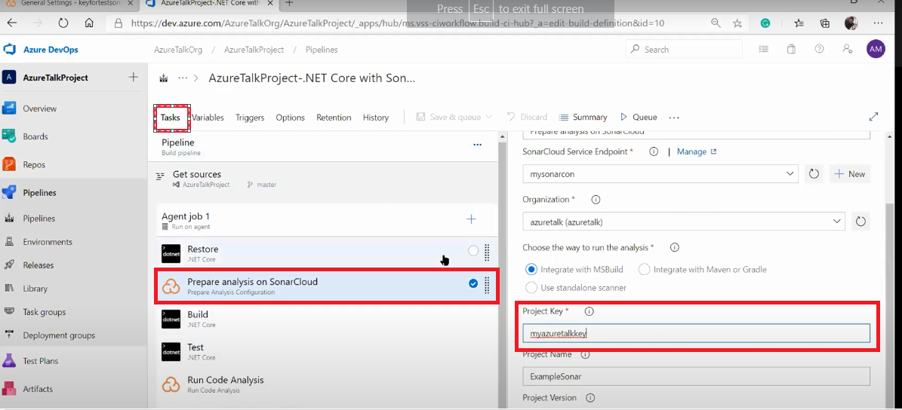

12. How you integrate selenium in your pipeline?

<https://www.youtube.com/watch?v=tcAMgPywsJA>

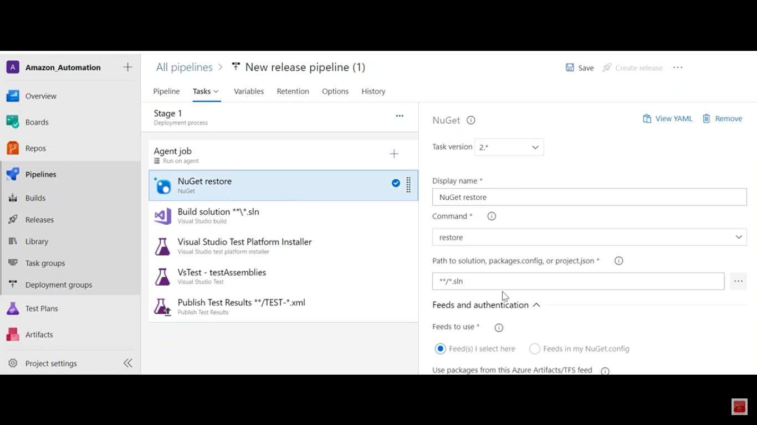

1. How you are handling branches in Azure DevOps
2. How can you deploy the code in Azure?

4. In CI what are the tasks you will configure

5. What task you needs to add in CI pipeline

8. How CI/CD Pipeline able to deploy the code in azure portal, eventhoug both are different domains

2. Branch startergy you are following from sprint to release?

Feature branching

A feature branch model keeps all of the changes for a particular feature inside of a branch. When the feature is fully tested and validated by automated tests, the branch is then merged into master.

Task branching

In this model each task is implemented on its own branch with the task key included in the branch name. It is easy to see which code implements which task, just look for the task key in the branch name.

Release branching

Once the develop branch has acquired enough features for a release, you can clone that branch to form a Release branch. Creating this branch starts the next release cycle, so no new features can be added after this point, only bug fixes, documentation generation, and other release-oriented tasks should go in this branch.

3. Once raise the pr what kind of branches you are configure?

4. Branch policies in azure repo

Isolate work in progress from the completed work in your master branch

Guarantee changes build before they get to master

Limit who can contribute to specific branches

Enforce who can create branches and the naming guidelines for the branches

Automatically include the right reviewers for every code change

Enforce best practices with required code reviewers

5. What kind of validations you will check when moving from featutre branch to dev branch?

6. What kind of tasks you will do for .Net application?

7. What is the artifact? What are the things you will deploy through CD?

1. What is Service connection in azure devOps

* ou will typically need to connect to external and remote services to execute tasks in a job. For example, you may need to connect to your Microsoft Azure subscription, to a different build server or file server, to an online continuous integration environment, or to services you install on remote computers.

You can define service connections in Azure Pipelines or Team Foundation Server (TFS) that are available for use in all your tasks. For example, you can create a service connection for your Azure subscription and use this service connection name in an Azure Web Site Deployment task in a release pipeline.

2. how can you will configure sonarcube in Azure DevOps

4. What is servive hooks in Azure devops

Service hooks let **you run tasks on other services when events happen** in your Azure DevOps projects.

5. Diff. b/w Jenkins & Azure DevOps

7. how can we know which build tool we needs to use for corresponding technology

1. how can configure sonarquebe - Self hosted agent - capabilities

What you are doing with Azure devOps

how many different types of pipelines are available in devops – **Declarative & Scripted**

what is the orchitecture of the application

how you are deploying the application with DevOps

how to make build pipeline in azure devops

what is the build agent?

What are the different components you deploy with azure devOps

What is ARM templates? For which purpose you are using ARM templates

Azure Test Plan:

Azure Test Plans are a service with Azure DevOps that provides a browser-based test management solution. The test plans also provide crucial capabilities in exploratory testing, user acceptance testing, and planned manual testing. Azure Test Plans also have a browser extension to provide exploratory testing alongside a collection of feedback from stakeholders.

8. As DevOps engineer, what are the good practices you advised to developers?

9. why we needs to add sonar qube in pipeline, why not in project solution?

10. what is the difference b/w developer & DevOps engineer?

11. How can you will deploy react js in azure in most optimized way?

12. How can you will findout, which host agent is responsible for the build?

13. How can you will execute parallel jobs in Azure pipeline

14.

## App Services:

|  |
| --- |
| How you deploy your application in webApp |
| 3. What is AppService  4. What is FunctionApps  9. Azure functions  10. what is serverless?  11. Who is responsible to execute server code for Azure functions? -**Worker Role**  https://azure.microsoft.com/en-in/blog/introducing-azure-functions-runtime-preview/  12. What is logic apps? How many logic apps you created so far?  13. What connectors you used so far for logic apps?  <https://docs.microsoft.com/en-us/connectors/connector-reference/connector-reference-logicapps-connectors> |
| How you will enable scalability in webApps  Are you migrated on premises application to azure appservices  Are you did any restAPI migrated to azure platform?  What is RestAPI?  18. What is WebAPI  8. what kind of pass services you used -Web Apps Mobile Apps Logic Apps Functions WebJobs  8. What are function apps and when u will use function apps  9. what are different types of functions can create in functionapps  * Durable Functions types  * Orchestrator functions  * Activity functions  * Entity functions  * Client functions  12. how can you will connect Azure app service with on premises database**- Hybrid connection manager**  10. How many ways function apps can trigger: HttpTrigger, QueueTrigger( Service Bus: any meesage will come, it will trigger)  <https://www.serverless360.com/azure-functions>  <https://hub.packtpub.com/anatomy-of-an-azure-function-app-tutorial/>  10. What is Scale up and scale down?  17. What are the pass services you are used in Azure  18. what is the function app/logi capp  19. how can you deploy these function app services with ARM template, Can we configure at deployment logic app/web app?  5. What kind of app services you used?  6. which purpose you used function apps?  7. App service slots?  5. What type of service plan you choose to create function apps – consumption plan  6. Types of app service plan  7. how can you will implement security to azure webapps              7. Explain about consumption plan  8. Which pricing you will refer when I go to the app service? |
| 9. 12. How can you implement webApp availability within corporate network only?  <https://www.youtube.com/watch?v=D87Wd4sjj7s> |
|  |
|  |
|  |
|  |
|  |
|  |
|  |
|  |
|  |
|  |
|  |
|  |
|  |
| how can logic apps call with api |
|  |
|  |
|  |
| Function Apps: Deccansoft conference  <https://www.youtube.com/watch?v=zuIEdnZSC4I&feature=youtu.be> |

What are other parameters are available for scale out apart from cpu percentage.

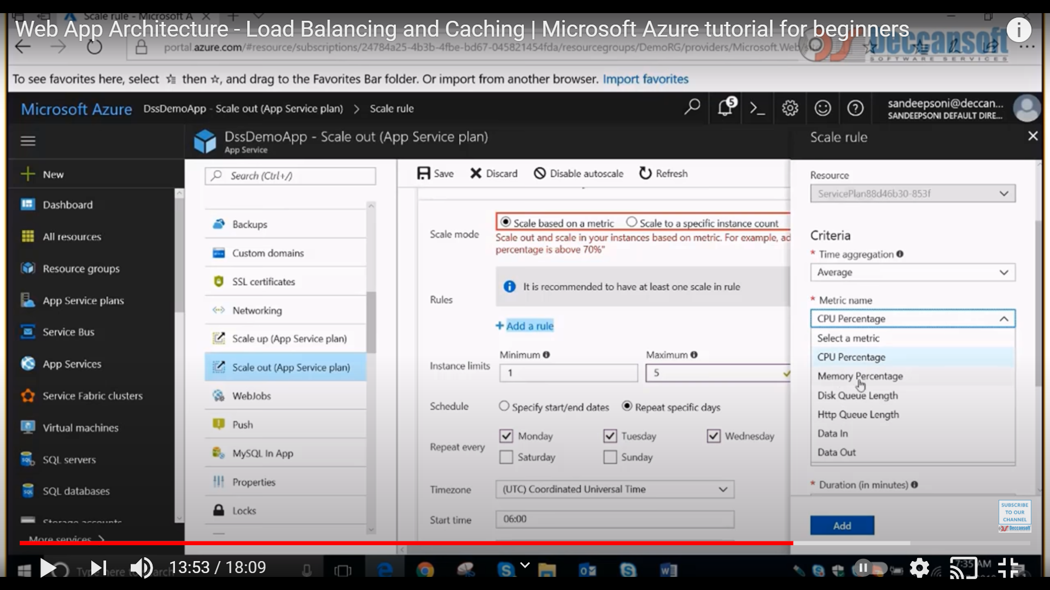

## Active Directory

|  |
| --- |
| how you will register your application in Azure active directory? -**Training video its available** |
| **Service principal in Active directory**  The Application is required to access certain resource of azure, again the identity for the user and the identity can be the programmer. If the program requires an identity, it will use the identity of app registration.  **2. how can you will provide authorization for apps in build pipeline** |

9. What you did with AD?

3. How can you implement monitoring and what you will configured.

4. what is AD and **Service fabric**

Azure Service Fabric is Microsoft’s Platform-as-a-Service (PaaS) and is used to build and deploy microservices-based cloud applications

2. What is multifactor authentication.

23. What is **service key vault**? Did u used key vaults?

12. how can you will migrate AD from on premise to cloud?

13. How you will manage AD to migrate on premises to cloud - **Azure AD connect tool**

13. how can you will integrate your application with Active Directory?

## Storage

What is deployment slots? What is web jobs?

Blob storage

20. what is web role and worker role

9. what is the storage and what you can use?

10. what is Share image gallery?

11. where you will store shared image gallery?

16. what are different storages we have

21. What are the blobs? For which purpose you used?

Types of Blobs: Block, page, append blobs

<https://docs.microsoft.com/en-us/azure/storage/blobs/storage-blobs-introduction>

**Block blobs:** store **text and binary data**. Block blobs are made up of blocks of data that can be managed individually. Block blobs store up to about 4.75 TiB of data. Larger block blobs are available in preview, up to about 190.7 TiB

**Append blobs**: are made up of blocks like block blobs, but are optimized for append operations. Append blobs are ideal for scenarios such **as logging data from virtual machines**.

**Page blobs**: store random access files up to 8 TB in size. Page blobs store **virtual hard drive (VHD)** files and serve as disks for Azure virtual machines. For more information about page blobs, see Overview of Azure page blobs

12. Where you will store the images of the react application?

## Azure SQL:

15. what is the diff. b/w export and backup in Azure sql

6. Any experience for NoSql like cosmos db

1. Cross database how can you will implement in azure

2. how can you will connect your webapp with on-premises database?

16. What is the diff b/w import and restore in azure sql

17. what is the extension of backup db? .bakpak

18. How can you will restrict to expose your database to the outside world (ie Private)

**#Private Endpoint**

We have to create “virtual network” -> under this needs to create “Private Endpoint ie( Private IP address)”

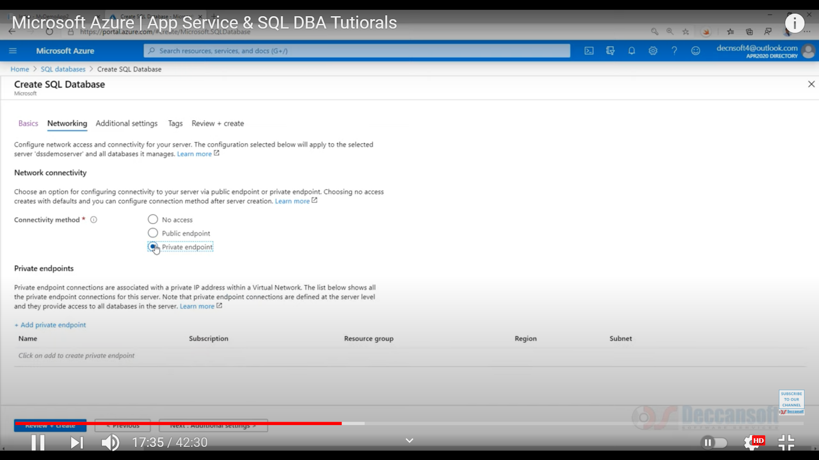

https://www.youtube.com/watch?v=gu8IjUOE2j4

18. How can you will connect Azure App with Azure Sql?

<https://www.youtube.com/watch?v=1j9OzWs89oo>

1. We have to go for Firewall settings of Azure SQL and needs to add “Client Ip”. We needs to select “Allow azure services and resources” under “Firewall settings” mode as “On”

2. WebApp changes: In WebApp, we have to select Settings -> Configuration -> Connection String -> here we needs to add new connection string

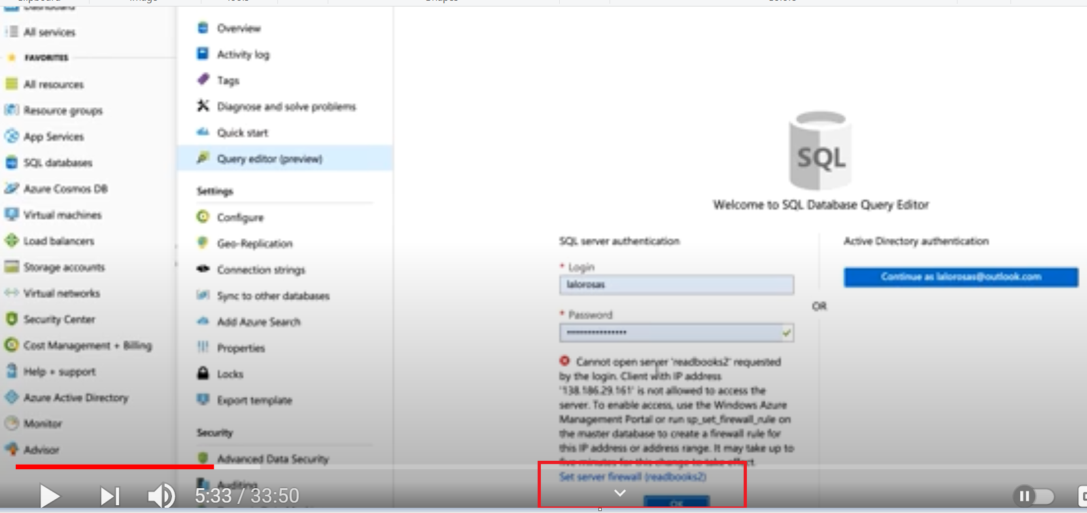

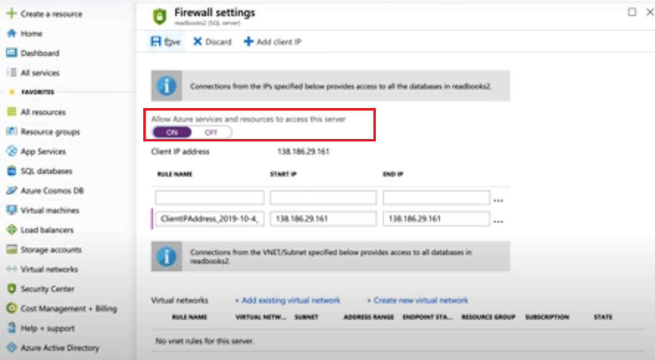

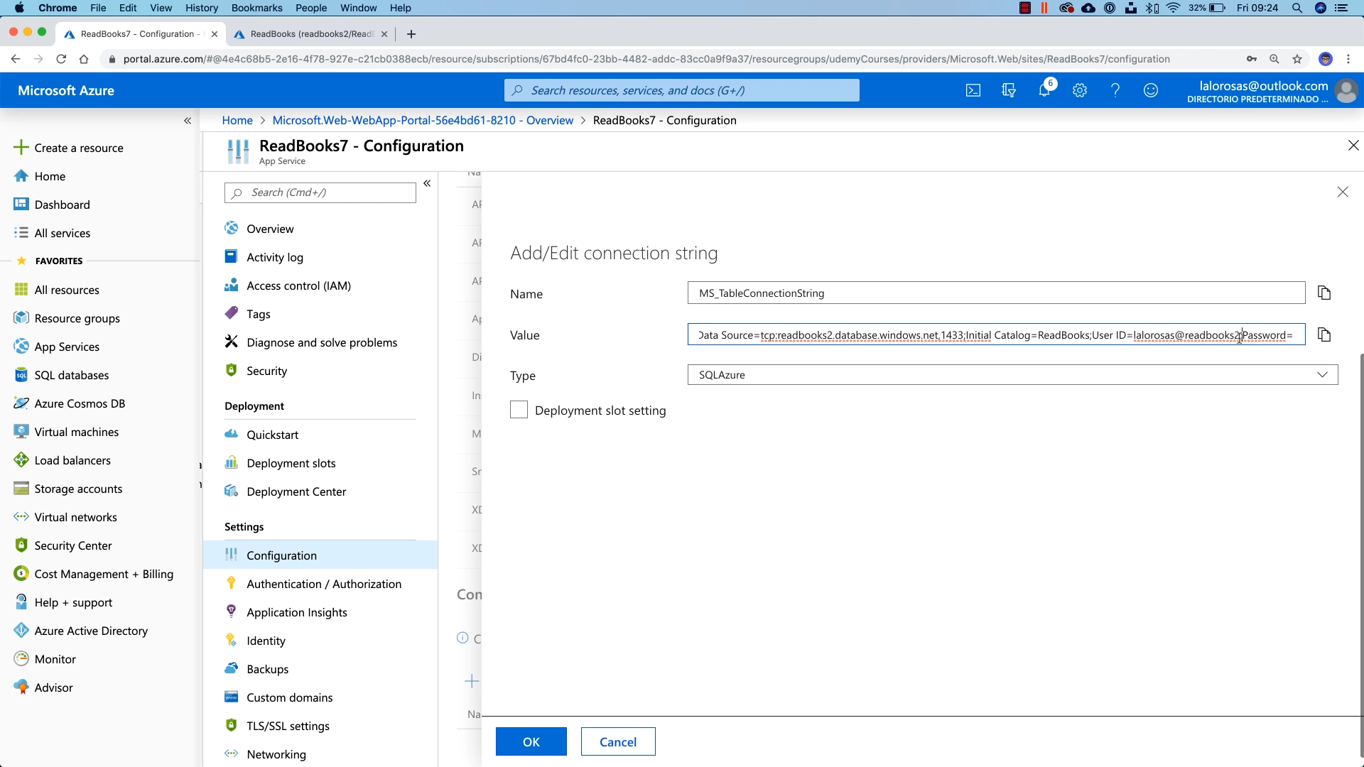

## Power shell:

Azure functions vs cmdlets

did you done any automation scripts using power shells

14. what you are automated as system admin?

9. What kind of customization you did by using powershell

|  |
| --- |
| 1. What is the difference between module & cmdlets |
| 2. What is cmdlets |
| 3. how can you will connect VM with powershell |
| 4. Write commands to create VM  11. Powershell & ARM templates  21. How strong in power shell script?  10. How can you implement 20 virtual machines?  11. Write a program in power shell to display primary number from given range?  What command to findout power shell version |

## ARM templates:

10. How you use ARM templates and which purpose?

<https://docs.microsoft.com/en-us/azure/devops/repos/git/branch-policies-overview?view=azure-devops>

2. how you push ARM template in to other environments

3. how can you will pass parameters into ARM template

4. how can you will create 10 virtual machines with ARM template

5. how to call one ARM template from another template

6. What are usual functions you used in ARM templates apart from Copy/CopyIndex

7. Top 5 function you used in ARM templates

8. How can you will fetch Azure key vault values in ARM templates

9. what is the linked template and nested template

10. What is SKU

11. Which No-Sql you used? For couche base in Azure, is it more cost compare with storage?

12. Cosmos DB is use JSON format? What is the plan we use for Cosmos DB?

13. In ARM templates, how can you will inject values from key vault from git hub

15. In ARM templates how can you will configure application insights?

16. What is the structure of ARM template?

17. Is ‘Output’ parameter mandatory for ARM template?

18. What is the default template for ARM template? **Template.json**

16. How can you deploy ARM templates with powershell

New-AzResourceGroupDeployment -ResourceGroupName "myRG" -TemplateFile sampleActivityLogAlert.json -TemplateParameterFile sampleActivityLogAlert.parameters.json

## Load Balance & Monitoring:

13. Having any experience with monitoring tools?

5. Load balancer and Monitoring in azure

24. For Azure monitor, what are the problem you encountered and how you resolve it.

25. Did you used application insights?

9. What you will advise to available the application for different regions. – traffic manager

10. Difference between load balancer and application gateway

10. Difference between load balancer and traffic manager

11. Private Linked service in Azure networking

12. what is subnet delegation?

14. how can you will configure diagnostic logs

## Serverless:

4. Message brokerage service, Event grid, event services, Service bus

Diff b/w Event Grid and Service BUS

7. What is ServiceBus

8. What is name space?

A namespace is a scoping container for all messaging components. Multiple queues and topics can reside within a single namespace, and namespaces often serve as application containers. This article provides instructions for creating a namespace in the Azure porta

## Azure tools

Data Migration tool: Helps to migrate sql server from on-premises to cloud.

**Hyper-V tool:** helps to migration from VM from on premises to azure

**Microsoft Azure Site Recovery vault**: helps to migrate from on premises to cloud.

Disaster recovery

## DevOps:

5. What is your experience with Azile? Which Methodology you are using?

7. how Agile related with DevOps

8. What is the major challenge you faced with DevOps

1. what is Continous Integration.

15. What are the code conflicts you merged to code in Azure devOps

6. How you will do configuration in Jenkins

12. What is release management

What you did with openShift?

16. what are the advantage with azure devOps while compare with Jenkins

20. IAC tool- Terraform you used?

22. Openshift, git

1. Who are involved in DevOps

2. How do you do CI

3. What is the diff. between Continuous Delivery & Continuous Deployment

4. What is containerization?

5. how two containers will communicate each other? **Internal IP**

6. What is dynatrace? And advantages

7. what are the advantages of open shift apart from auto scale

8. In Azure also we are having auto scale. Why we required open shift auto scale

15. difference b/w git and source tree

16. difference b/w git and GitHub

1. What is the namespace in kubernetes.

**Kubernetes** supports multiple virtual clusters backed by the same physical cluster. These virtual clusters are called **namespaces**

6. Did you use Teraform?

4. which tools you are using code coverage? SonarQube

7. how can you will configure the build for each commit? **Poll SCM**

|  |
| --- |
| **GIT:** |
| 1. How can you will configure the build with different version of VS – **Global tool configuration -> Version** |
| 2. How you will configure the build for different environments with jenkin |

**This project is parameterized check box will help**

3. What is branching strategy?